Social engineering One may invest significantly on state-of-the-art firewalls, trusting in their efficacy; however, the fundamental vulnerability persists in practically every company. It remains uncomplicated. The human factor is paramount, and while this may seem somewhat disheartening, we will demonstrate this today. The most successful attacks are not merely contingent upon luck or charm; they are systematic in nature. We are examining the exact schematics. Researchers refer to attack templates that delineate the planning and execution of these attacks, emphasizing that understanding these blueprints may be the most effective method for developing functional security training. Therefore, let us define this appropriately.
We are not merely discussing being deceived by an arbitrary scammer; rather, the research delineates social engineering as a more formal concept. It is persuasion directed towards achieving a technological result by eliciting compliance with a request involving a computer-related entity. It constitutes manipulation with a technical objective, and the basis for deconstructing this phenomenon lies inside the social engineering attack framework; that is all. Kevin Mitnick's traditional attack cycle is elaborated into six separate phases that encompass the entire duration of the attack, from initial investigation to final cleanup. Let us examine this structure in detail.
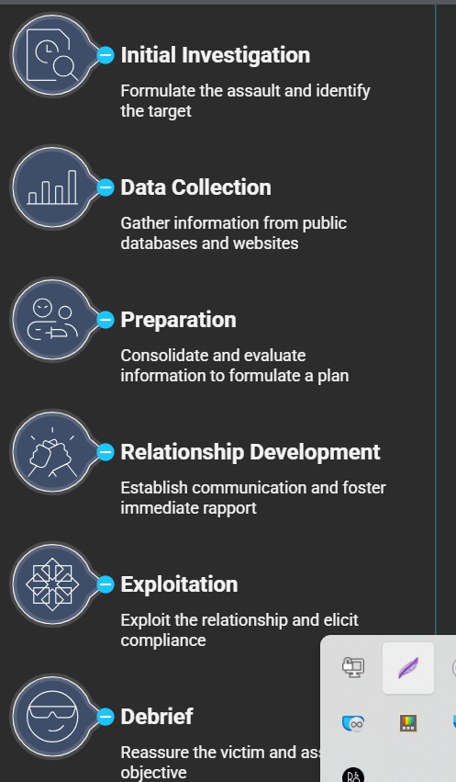
The process consists of six steps, with the initial stages mostly focused on preparatory actions that the victim remains oblivious to, occurring well before the target becomes conscious. The initial phase involves formulating the assault, specifically determining whether the objective pertains to financial data. The process involves installing a backdoor and identifying the target. Subsequently, data collection occurs, which is a cyclical phase involving the gathering of information from public databases, corporate websites, and perhaps monitoring personnel. Context is essential, and once all data is acquired, the next step is preparation.
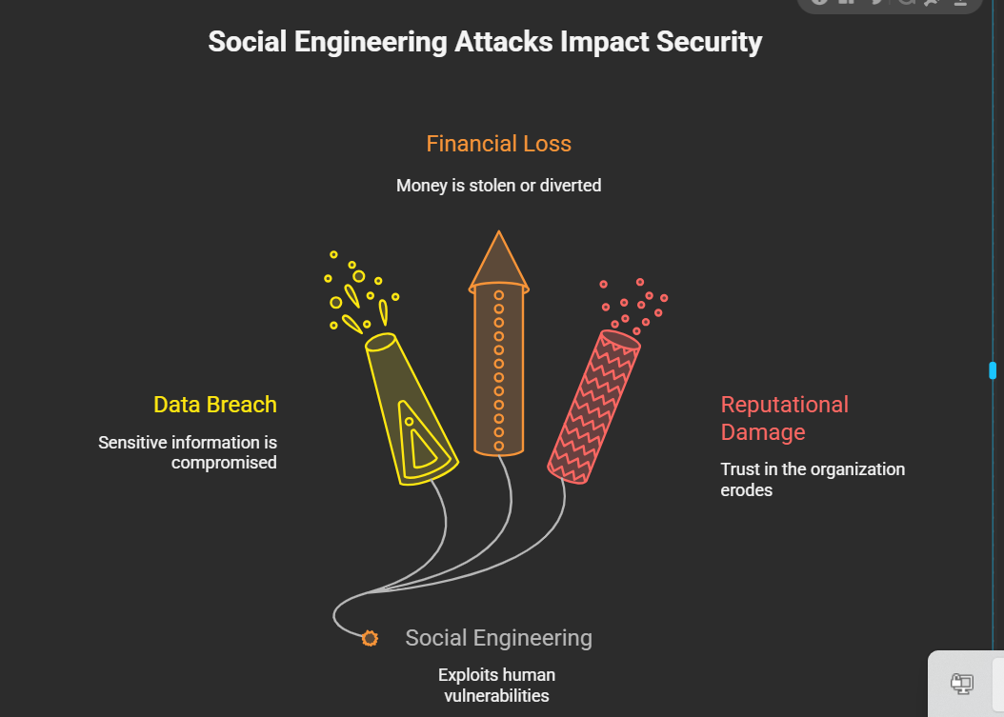
This is the stage where you consolidate and evaluate all the information to formulate a specific assault vector; thus, that constitutes the plan. The strategy involves employing methods such as forecasting your fishing and determining which psychological triggers to activate. While this process is meticulous, the critical aspect lies in how they establish contact and execute the heist without arousing suspicion. This is where human interaction becomes pivotal, particularly in phases four through six.
The execution of cleanup phase 4 involves relationship development, establishing communication, and fostering immediate rapport or trust. Subsequently, in critical moment phase 5, the relationship is exploited, which consists of two components: first, priming the target to feel urgency about compliance, followed by elicitation. The genuine request followed by the phase 6 debrief.
The debrief phase, though often concealed, is crucial for the attacker. It encompasses maintenance, wherein the attacker reassures the victim to mitigate suspicion, and transition, where the objective is assessed. Ultimately, this phase underscores that a successful attack involves more than mere infiltration. The objective is to induce a sense of satisfaction or relief in the victim regarding their actions, ensuring they remain unsuspecting and, importantly, refrain from reporting the incident. This is fundamentally reliant on the fifth phase, the exploitation, which is propelled by psychological compliance principles. If the attacker can leverage one or more of these principles, they effectively circumvent the target's defenses. analytical reasoning Let us commence with two of the most significant authorities and those that are limited in authority.
This is quite simple. Individuals are inherently predisposed to acquiesce to requests from those perceived as possessing higher authority. Consequently, an attacker must effectively impersonate a manager, IT support, or even law enforcement. They exploit the reality that, in many organizations, employees often feel they lack the autonomy to refuse. Additionally, tactics such as creating a sense of urgency—claiming an offer expires within 24 hours—instigate a fear of loss, prompting the target to abandon critical evaluation of legitimacy in favor of immediate action. This constricts the decision-making timeframe to virtually nothing. Furthermore, if the attacker can establish common ground and foster rapport, compliance likelihood significantly increases, which is associated with the principle of reciprocity. When an attacker performs a minor favor initially, the target experiences a psychological compulsion to reciprocate when the genuine request is made. Lastly, the concepts of commitment and consistency, along with social validation, further influence compliance behavior. You consented to a minor action, such as clicking a link, which psychologically predisposes you to undertake a more significant action, like entering your password on the subsequent page. Having initiated this process, you feel a sense of commitment. Social validation is a time-honored tactic; individuals tend to comply when they perceive an action as socially acceptable or when it appears that others are engaging in it. Thus, these principles serve as effective instruments. The assault templates delineate their implementation, with academics categorizing them into three formal types: direct, unit directed, and indirect.
This assists security models in evaluating the consistency of these risks; let us commence with directed communication. We are both individuals engaged in direct conversation, either in person or via telephone, utilizing our initial template. This pertains to obtaining physical access using Pric messaging and the authority principle we previously discussed in the situation. An assailant attempts to access a company computer by employing pretexting, masquerading as a high-ranking individual, possibly from management, while the victim is a subordinate, such as a janitor. This illustrates the sophistication of the preparation involved. They select an individual with physical access to the premises, yet likely possess limited authority to scrutinize a request for management over a cleaning that appears too particular.
Most attacks typically target the financial department or similar sectors. That exemplifies the ingenuity of the path of least resistance. Finance departments are conditioned to be wary; however, cleaners, despite their significant physical trust inherent in their roles, typically receive no training on verification. They often believe they are merely being helpful, which can lead to attackers installing a backdoor, leaving the victim completely oblivious to the fact that the maintenance was executed flawlessly. What if the attacker is unable to engage in face-to-face interaction? How do they enhance their skills, similar to phishing, by transitioning to directed communication? The classic phishing attempt, commonly executed via SMS, typically targets your login credentials. The text message is accurate. An alert from a system provider indicates a necessary product upgrade, utilizing a scarce, complimentary update available for a limited time. Immediate action is required, accompanied by a short link that directs the user to a login screen.
That appears entirely recognizable and wholly authentic; therein lies the dominance of dedication and constancy. They have already clicked the link, hence they are compelled to complete the process by inputting their credentials. The fraudulent site collects the data, expresses gratitude, and redirects users to the legitimate system. The onslaught is seamlessly devious; the entire defense collapses in that instant. You have chosen to click the link; what is your perspective on the final category of indirect communication? This is a situation devoid of genuine dialogue. The media itself constitutes the message; for instance, the utilization of a physical storage device, commonly depicted in popular culture, is highly effective. The attacker employs a USB flash drive embedded with malware, exemplifying the famous USB stick tactic.
Mr. Robot popularized this, although it is a genuine formalized framework. Men, social affirmation, and basic inquisitiveness to establish connections The drive is frequently emblazoned with the company's logo and prominently labeled as "Confidential Q4 Bonus Data," ensuring that the target discovers it in the parking lot. They are not merely inquisitive; they believe they are engaging in socially appropriate behavior by attempting to return the gadget to its owner, which inadvertently triggers the virus that installs a backdoor.
The attack leverage is basic human ethics to turn the target into an insider threat without them ever knowing so we have these really comprehensive attack templates Documenting each phase from inception to completion necessitates the meticulous formalization of the assault framework in this manner. What is the purpose of the principal utilities employed? Defense validation templates are crucial for evaluating security measures, particularly models such as the Social Engineering Attack Detection Model (SEMD). Without a credible attack scenario, it is impossible to ascertain whether your defense model is effective against realistic threats. The object itself, namely the infected USB stick, inherently prompts you to investigate its contents. The model must encompass both aspects.
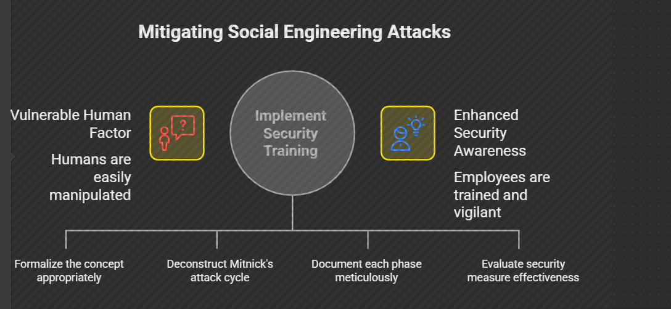
How does an attack occur? Could you provide us with an illustrative example? Utilize the directed male paper template. contemplate a fraudulent charity scheme The phishing letter seeks financial gain, disguised as a legitimate charity, and use scarcity to ensure its delivery. The recipient receives the letter and begins reviewing the model assessments. The model verifies that the individual comprehends the request for a donation is not an emergency, as they have not reached a critical defense threshold. It inquires whether the request can be validated by a third-party source, as this is the requisite protocol. This is it; despite the letter appearing entirely authentic, it contains all the appropriate logos and contact information. The approach instructs the recipient to contact the legitimate organization using an unverified trustworthy number. The entity referenced in the letter is not the correct one; they make the call, and the legitimate charity denies sending that letter, indicating that the verification process has failed.
The attack has been communicated; what does this signify for you? The audience understands that effective protection does not stem from a miraculous technological solution. It arises from the necessity of having obligatory recorded procedures and, crucially, employing critical thinking at the time of the request, prompting one to consider whether the situation feels atypical. May I authenticate this by an alternative reliable channel? The intricate nature of these complexities demonstrates that social learning is a systematic science rather than a mere arbitrary phenomenon. It is methodical planning that focuses on particular human vulnerabilities, and this is the paramount importance of possessing a precise, repeated assault.
Flow enables organizations to develop training that is directly relevant to their environment, utilizing their own departments and logos. You are transforming this knowledge into practical tailored defense. Here is a concluding outline for the debrief phase: if these meticulously detailed attack scenarios demonstrate the efficacy of our security models, what percentage of actual successful attacks remain entirely unreported due to the victim being effectively reassured by the attacker, thereby never suspecting they were targeted? Precisely. Consider your response if you encountered a USB drive or received an unusual SMS update request. What obligatory internal protocol would you adhere to prior to initiating any action?
